Inventory Management Form Project Presentation

Introduction
- Project Goal: The main objective was to develop the front- end data entry component for an Inventory Management System (IMS) that is both functional and provides a superior user experience (UX). The form’s success is measured by its usability and aesthetic design, which promotes accurate and efficient data recording, a critical factor for efficiency in operation.

II. Foundation: Semantic HTML Structure
- Data Integrity: The HTML structure is designed to carefully capture all necessary inventory data: Item Name, item Id, Category, Condition, Quantity, Unit Price, Supplier, and Date Received.
- Structure and Accessibility:
• Makes use of semantic HTML5 elements, such as <form>, <label>, and <input>.
• To ensure availability for all users, proper label association is applied.
- Validation and Typing:
• Inputs use specific types, such as type="number" for Quantity and Price, and type="date."
• The required attribute is included to ensure data completeness before submission.

III. Modern CSS & UX Design
- Visual:
- Background: The body uses a linear-gradient overlay on a background image for a modern, visually engaging look, creating a sense of a branded application.
- Container: The form (.frm) uses a white background, rounded borders (border-radius: 13px), and a strong box-shadow to make it visually pop against the background.
- Responsive Design Principles:
- The form container is fluid (width: 100%) but restricted by a max-width: 480px, ensuring it is fully responsive and looks great on both mobile devices and desktop screens.
- Enhanced Input Clarity (Iconography):
- Key input fields (Item Name, SKU, Quantity, Price, Supplier) utilize the .frm-input-logo class.
- CSS background-image is used to display context-specific icons (e.g., a dollar sign for price) directly within the input field, guiding the user and adding polish.
- Intuitive Selection (Radio Buttons):
- The standard radio buttons are hidden (display: none;).
- Customized <label> elements are styled with backgrounds and borders.
- The: checked + label pseudo-selector provides a clear, gradient-filled visual confirmation when a condition (New, Used, Refurbished) is selected.
- Feedback and Action (Button Design):
- The "Add Item to Stock" button uses a vibrant linear gradient.
- The:hover state includes a subtle transform: translateY(-3px); and an increased shadow, providing immediate, satisfying visual feedback to the user that the element is clickable.

IV. Maintainability and Scalability
- Separation of Concerns:
- The code is highly maintainable due to the clear separation of structure (HTML) and styling (external CSS file, style.css).
B. Modular Class Naming:
- Reusable class names (e.g., .frm-input-logo, .radio-group) allow developers to apply consistent styling across different forms or future parts of the application with minimal effort.

Code of CSS for style:
- Basic structure of the webpage:
- <!DOCTYPE html>
- <html>
- <head>
- <body>

- Page information and external files:
- <meta>
- <title>
- <link>

- Heading Tag
- <h1>

- Form Control & Input Tags
- <input>
- <select>
- <option>
- <button>

- Label Tag
- <label>

- Special Input Types Used
- type="text"
- type="radio"
- type="number"
- type="date"
- type="submit"

Form Attributes Used
- action
- method
- id
- class
- name
- placeholder
- required
- min
- step
- value

- Styling & Layout Attributes
- class
- style

- Accessibility & Viewport Attributes
- lang
- charset
- viewport
- for

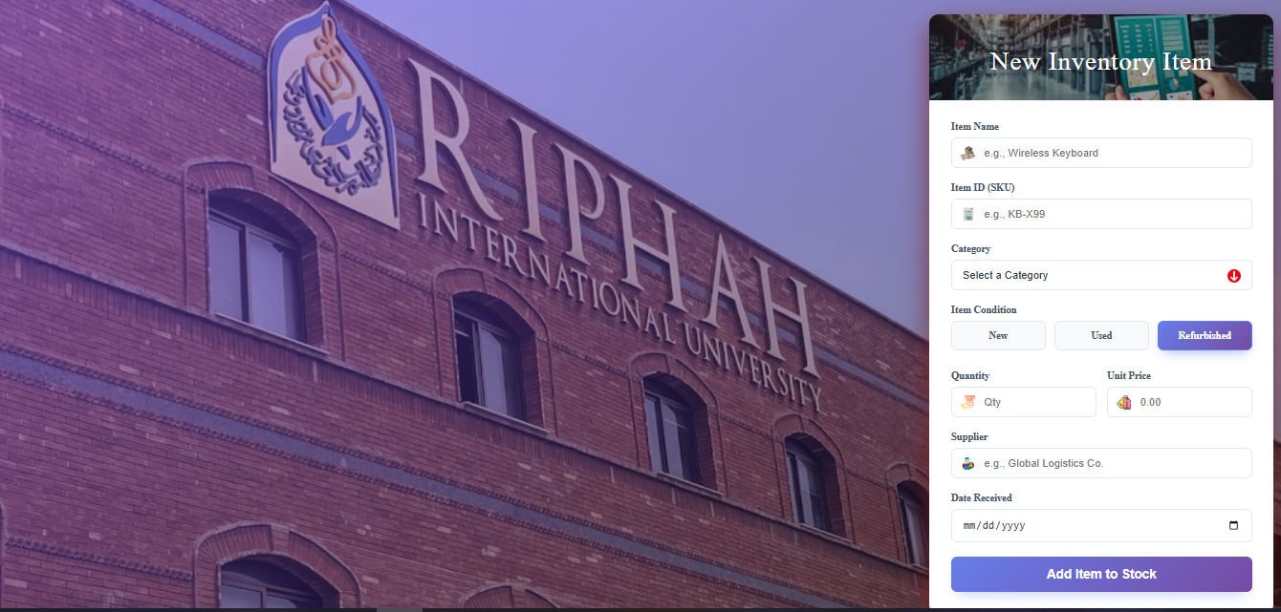
Figure:

V. Conclusion
A. Summary:
- This project successfully implemented a core business function—inventory data entry—by applying modern web development practices to ensure superior UX, visual consistency, and a foundation for system scalability. The design choices were deliberate in making the data capture process efficient and engaging.
- Next Steps:
- Future development would focus on adding client-side validation using JavaScript and integrating the form with a back-end database for data submission and storage.

